REPORTS - REPORTS

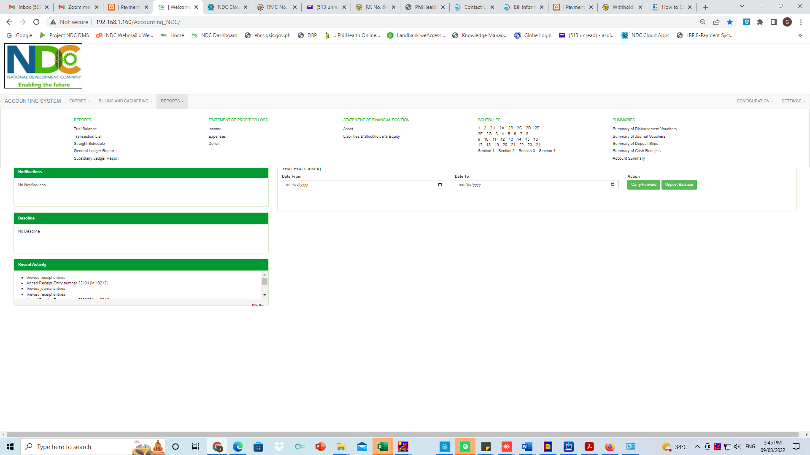

REPORTS

* TRIAL BALANCE

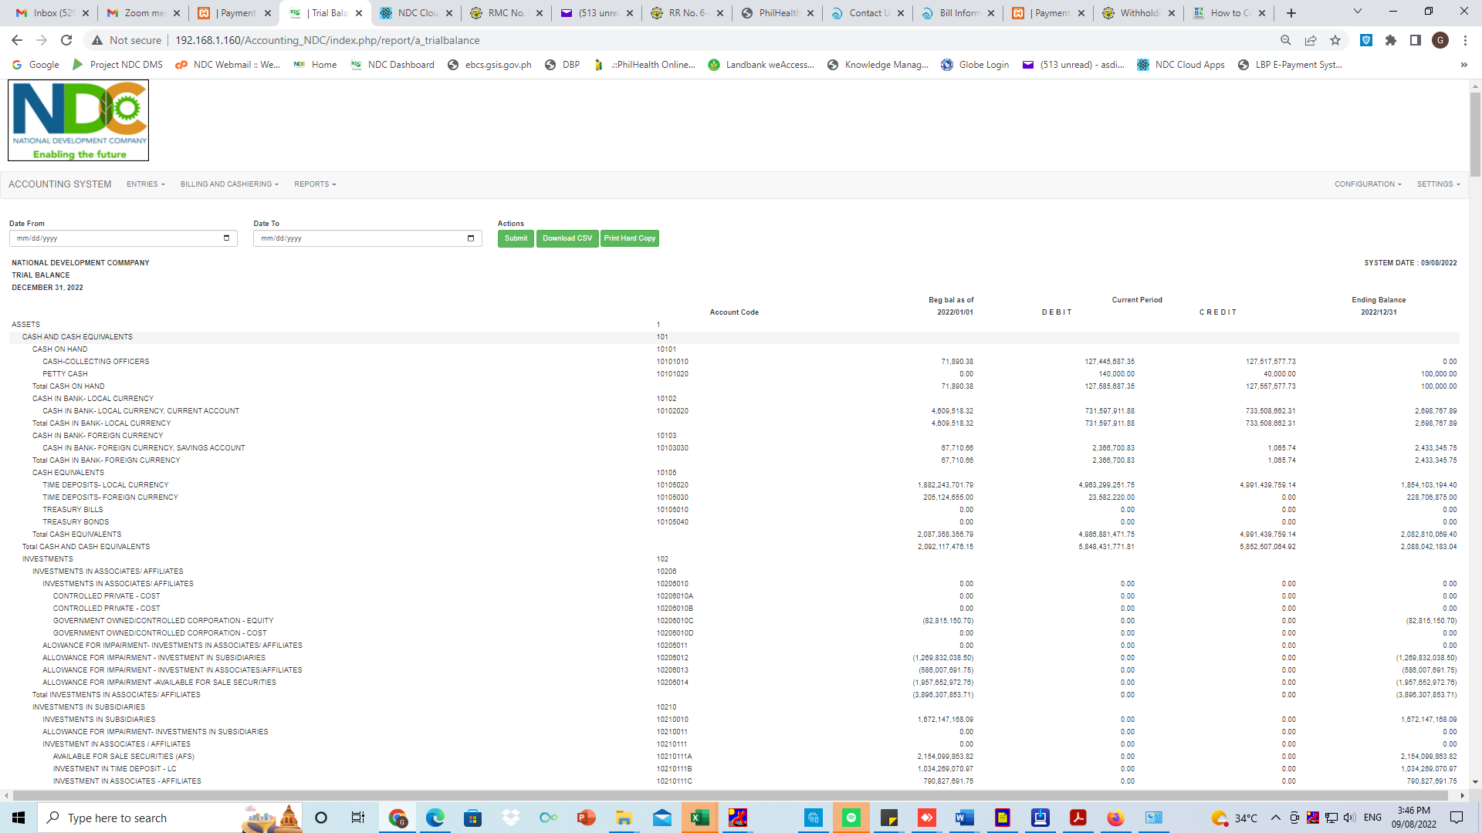

REPORTS

* TRANSACTION LIST

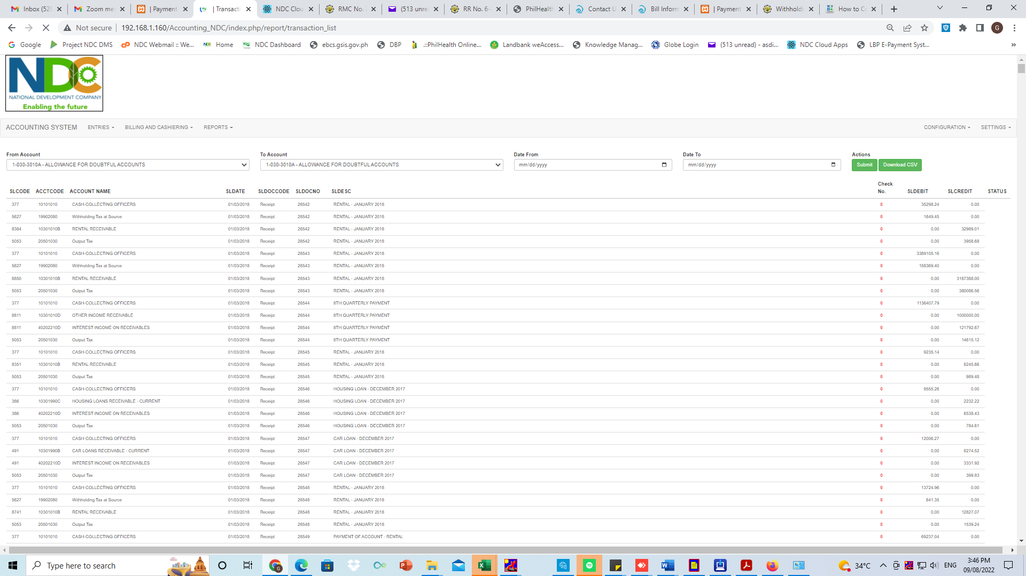

REPORTS

* STRAIGHT SCHEDULE

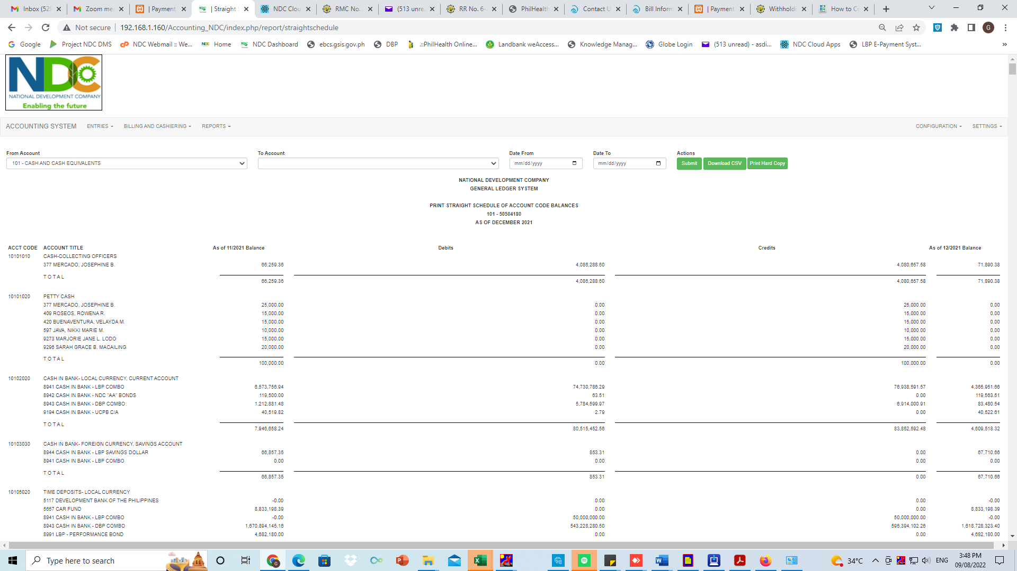

REPORTS

* GENERAL LEDGER REPORT

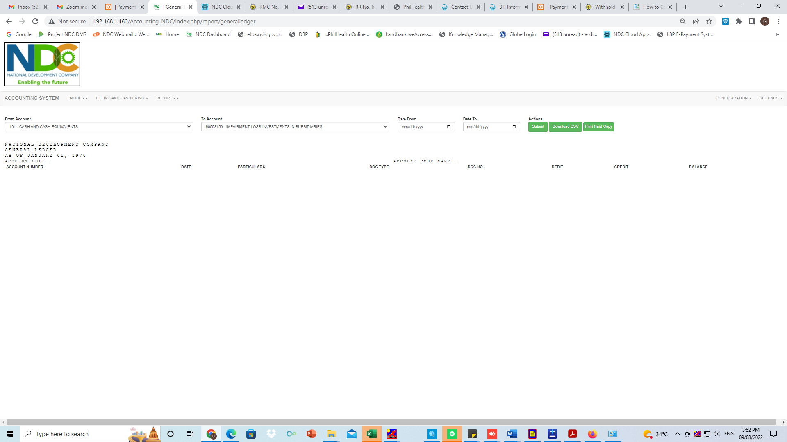

REPORTS

* SUBSIDIARY LEDGER REPORT

